Q4 code-

A. #include <iostream>

using namespace std;

int main() {

int arr[100], n;

cout << "Enter number of elements: ";

cin >> n;

cout << "Enter " << n << " elements: ";

for (int i = 0; i < n; i++) {

cin >> arr[i];

}

for (int i = 0; i < n / 2; i++) {

int temp = arr[i];

arr[i] = arr[n - i - 1];

arr[n - i - 1] = temp;

}

cout << "Reversed array: ";

for (int i = 0; i < n; i++) {

cout << arr[i] << " ";

}

cout << endl;

return 0;

}

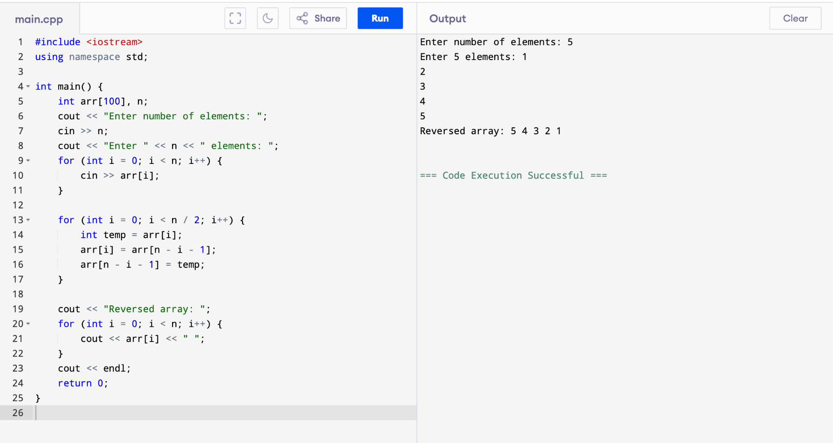

B. #include <iostream>

using namespace std;

int main() {

int a[10][10], b[10][10], c[10][10], r1, c1, r2, c2;

cout << "Enter rows and columns for first matrix: ";

cin >> r1 >> c1;

cout << "Enter rows and columns for second matrix: ";

cin >> r2 >> c2;

if (c1 != r2) {

cout << "Matrix multiplication not possible." << endl;

return 0;

}

cout << "Enter elements of first matrix:\n";

for (int i = 0; i < r1; i++)

for (int j = 0; j < c1; j++)

cin >> a[i][j];

cout << "Enter elements of second matrix:\n";

for (int i = 0; i < r2; i++)

for (int j = 0; j < c2; j++)

cin >> b[i][j];

for (int i = 0; i < r1; i++) {

for (int j = 0; j < c2; j++) {

c[i][j] = 0;

for (int k = 0; k < c1; k++) {

c[i][j] += a[i][k] \* b[k][j];

}

}

}

cout << "Resultant matrix:\n";

for (int i = 0; i < r1; i++) {

for (int j = 0; j < c2; j++) {

cout << c[i][j] << " ";

}

cout << endl;

}

return 0;

}

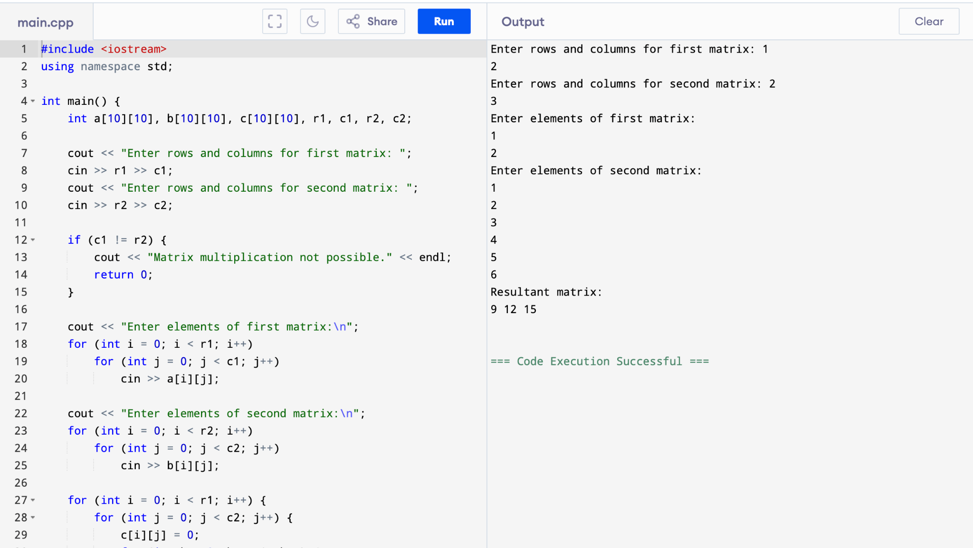

C. #include <iostream>

using namespace std;

int main() {

int a[10][10], transpose[10][10], rows, cols;

cout << "Enter rows and columns of matrix: ";

cin >> rows >> cols;

cout << "Enter elements of matrix:\n";

for (int i = 0; i < rows; i++)

for (int j = 0; j < cols; j++)

cin >> a[i][j];

for (int i = 0; i < rows; i++)

for (int j = 0; j < cols; j++)

transpose[j][i] = a[i][j];

cout << "Transpose of the matrix:\n";

for (int i = 0; i < cols; i++) {

for (int j = 0; j < rows; j++) {

cout << transpose[i][j] << " ";

}

cout << endl;

}

return 0;

}

